|  |  |  |  |  |  |  |  |
| --- | --- | --- | --- | --- | --- | --- | --- |
|  | | | |  |  |  |  |
|  |  |  |  |  |  |  |  |
| **Student ID Number**  *(Do not include student name as anonymous marking is implemented)* | Mateusz Utracki-Janeta | | | | | | |
| **Programme Title** | BSc Computing Technologies | | | | | | |
| **Module Title** | Data Modelling and SQL Language | | | | | | |
| **Module Code** *(listed on Moodle and in LTAFP)* |  | | | | | | |
| **Module Convenor** |  | | | | | | |
| **Coursework Title** | Jet Airline DBMS | | | | | | |
| **Academic Declaration:**  *Students are reminded that the electronic copy of their essay may be checked, at any point during their degree, with Turnitin or other plagiarism detection software for plagiarised material.* | | | | | | | |
| **Word Count** | 1557 | | | **Date Submitted** | | **22/07/2019** | |
|  |  | | |  | |  | |
|  | | | | | | | |

Table of Contents

1. Introduction 3

2. Understanding database 3

3. Conceptual modelling 5

4. Logical modelling 7

5. Physical modelling 9

5.1. DDL Statements 10

5.2. DML Statements & airports.csv 12

5.3. Screenshots from phpMyAdmin 15

6. References 23

7. Appendix 24

# Introduction

These days we are surrounded by data. Whether we go to the shop buy milk, watch our favourite show on line, or go to bed with our fitness tracker, data is being collected and we are interacting with databases not even being aware we do. That’s the future and we are living in it.

Even thought databases are all around us, majority of people don’t know how they work and what exactly are databases? During academic year 2019/2020 I learned about Data Modelling and SQL Language and in this report, I will explain the meaning and purpose of databases, difference between ways of handling data and many more based on case study scenario of Jet Airline.

# Understanding database

According to assignment scenario Jet Airline international airline company who is looking to develop an effective RDBMS and me as a junior developer was assigned to this task. They gave me some directions on what sort of data they want to collect, my job was to create data base model based on given information.

According to (Conolly, 2015) **database** is a structured, collection of data, it is usually stored and access through computer or digital system. Data in database can be accessed, changed, removed, when needed, this is done more easily and error free when using a **Database Management System (DBMS).**

**DBMS** is a software bundle intended to characterize, control, recover and oversee data in a database. A DBMS for the most part controls the data itself, the data group, field names, record structure and document structure. It likewise characterizes principles to approve and control this data. A DBMS mitigates clients of encircling projects for data upkeep. (Techopedia, 2019) Apart from DBMS there are different way to organize and then access data.

Before DMBS originated, there was **File Management System,** it is a collection of application programs that perform services for end users. Each of these programs defines and manages its own data.

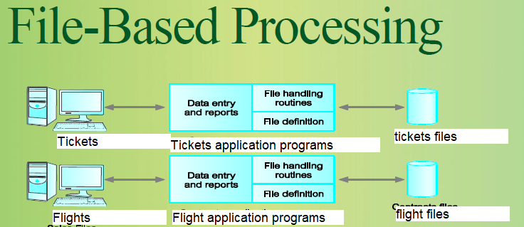

Fig 1

Based on our JetAir example we would have a program for controlling sales of tickets and a second program collecting and controlling information about flights. One user works on sales of tickets program, other user works on flights program. In this situation sharing data is very complex or nearly impossible. We can hold the same data, in many programs, data is being duplicated and takes unnecessary space. Data is being separated and users may not know that the program is holding useful data. To top up disadvantages of this approach programs are being written in different languages that makes them harder to share files, queries are fixed and if you want a new functionality, you need to get a new program.

**DBMS** has many advantages, it allows you to access multiply tables at once, generate queries, and have personalised views, which are sub-sets of database. Data is logically modelled and related. A software system that enables users to define, create, maintain, and control access to the database. A DBMS consistently gives data autonomy. Any adjustment in storage mechanism and format are performed without changing the whole application. (Techopedia, 2019)

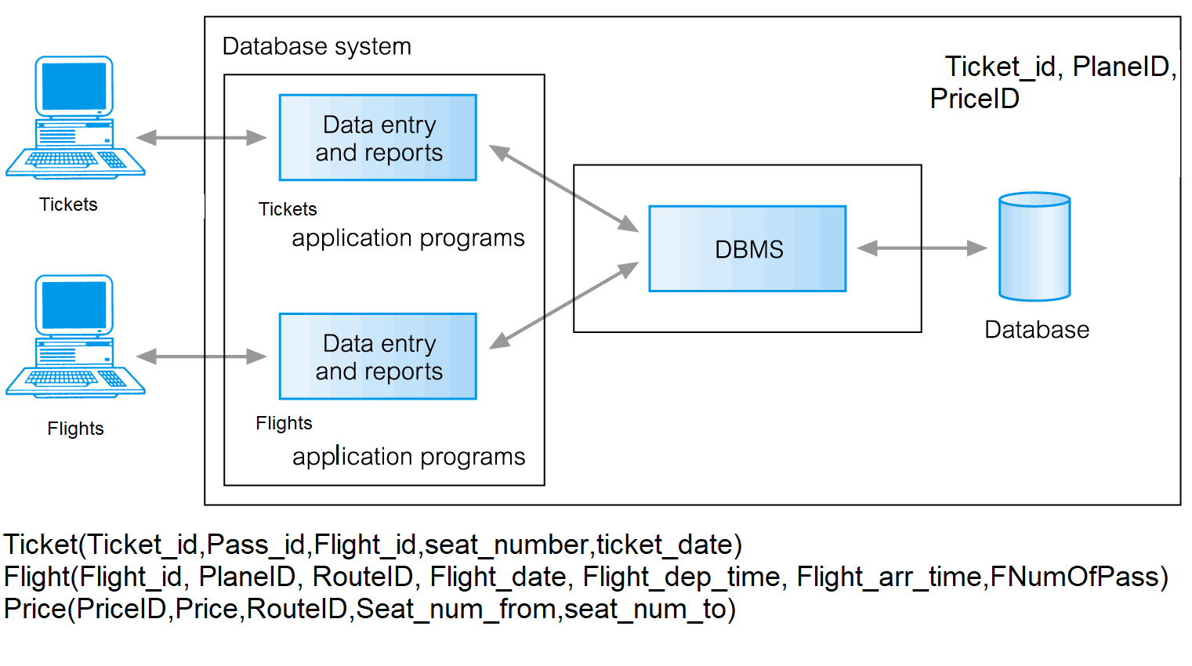

Fig 2 DBMS

**Data model** is a conceptual model that arranges components of data, shows and standardises, the relationship between one another and properties of the real-world entities. Below there are some data models and their descriptions.

* **Hierarchical Database** – One of first-generation database system.



Fig 3

The hierarchical model is comparable to the model of the network except that connections form a tree structure in the hierarchical model while the model of the network enables arbitrary graph. When the one-to-many connection is breached, it becomes a complex network. (Techopedia, 2019) Hierarchical databases are still commonly used today, particularly in apps requiring very high output and accessibility such as banking and telecommunications. One of the commercial hierarchical databases most commonly used is IMS. 7. (IBM, 2019) Windows Registry in Microsoft Windows operating systems is another instance of using hierarchical databases. (Microsoft, 2018)

**Network Model** - A network model is a database model that is structured as an adaptable way to deal with object representation and their connections.



Fig 4

The network model's distinctive characteristic is its schema, which is regarded as a graph where arcs are relationship kinds and nodes are object kinds. You can analyse a network and answer questions with logical network information, many of which are related to path computing and tracing. For instance, you can discover all possible response pathways between two chemical compounds for a biochemical pathway. (Oracle, 2019)

* **Relational Database** – it is a second database system generation. Connections between tables are shown by shared information. Data is sorted as tables that are logically independent. The information in a table can reference similar information in various tables, thus maintaining the integrity of the links between them. This component is referred to as referential integrity–an important concept in a scheme of relational databases.

A **top-down** methodology is utilized to make database. You model the items at a logical level, at that point you apply the objects to a physical database structure. For instance, a relational database would require the items to be mapped to tables. To describe a real-world model, we can assume that a finance system will have individual items, together with other items that hold rules of pay (payment for overtime, holiday pay, etc). There would be a payroll interval that holds the dates of the payroll interval and pay day. This depiction is anything but a complete plan. Working more on application, uncovers additional features you have to add. The top-down approach will attempt to define the large image and all its elements. The top-down technique may also have weaknesses. In some instances, top-down design may result in unsatisfactory outcomes because the analyst and end-users may miss something that is essential to the scheme and required. (Burleson, 2017)

The approach from the **bottom-up** starts with the specific data and moves to the general. The system analyst will check all the interfaces the system has, checking reports, screens, and forms to start a bottom-up design. Through the scheme the analyst will operate backwards to determine which information should be stored in the database. (Burleson, 2017) The bottom-up approach might be used when you are migrating one physical database to another. You would have to create table based on the existing tables or you will have to alter the table structure, usually to normalize further or to group columns together in a more logical way.

In my work I used top-down approach, it felt more suitable for the task, I didn’t have to match ant pre-existing columns or tables and worked my way, from requirements to the design. While performing task I had to go back and rethink my design because something was missing, like for example: reservation table at one point I hadn’t got one.

# Conceptual modelling

Based on the assignment scenario I identified entities:

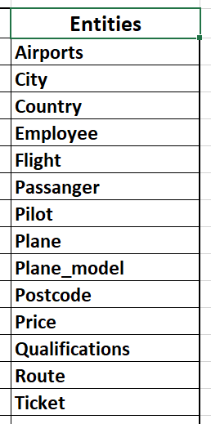

Fig 5

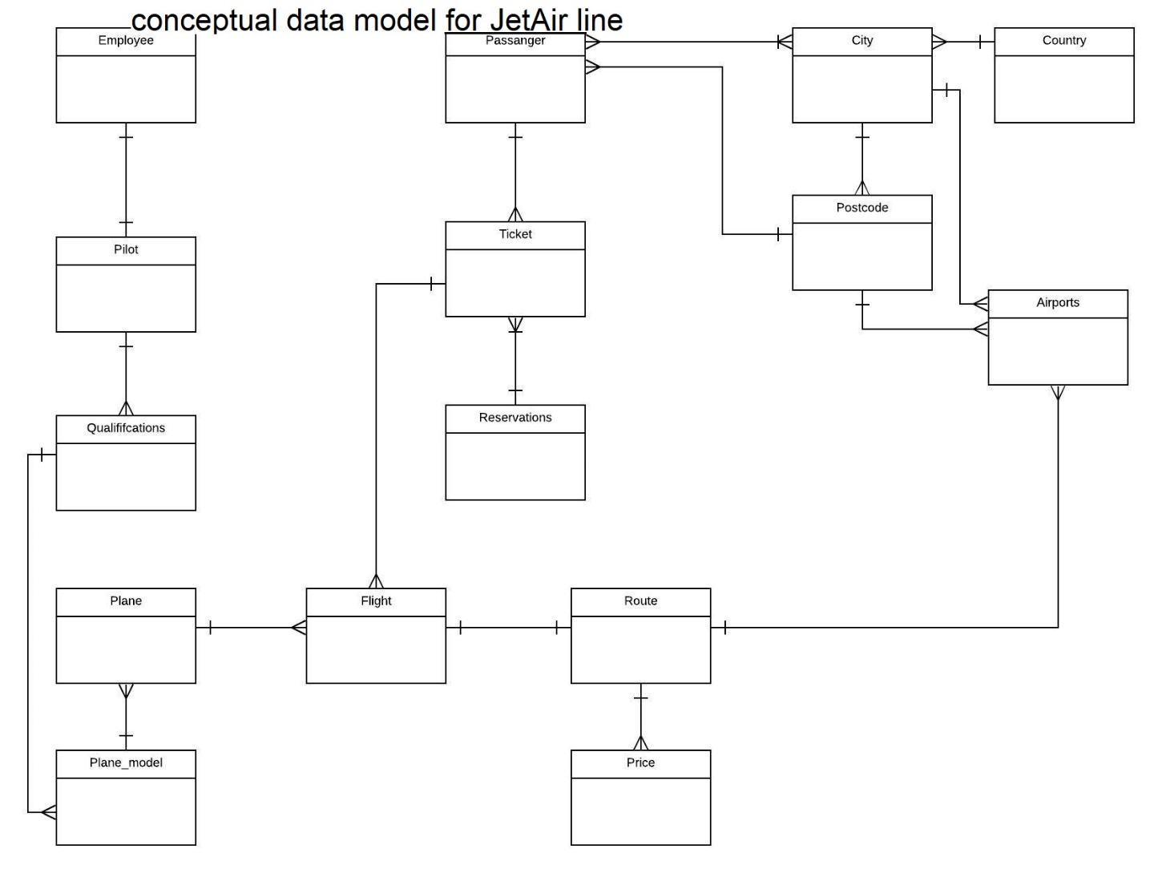

Fig 6

# Logical modelling

Fig 7

On left side you can see Fig.7. It shows the normalization table. When from UNF which is not normalized data we go all the way through 1NF, 2NF to 3NF and I am going to explain the process below.

Normalization is the data organisation method in a database. This involves creating tables and establishing relationships between those tables in accordance with guidelines intended to safeguard data as well as make the database more flexible by eliminating redundancy and inconsistent dependence. (Codd, 1990)

**1NF** Eliminate in individual tables repeating groups, for each set of associated data, create a distinct table and identify a primary key for each collection of associated information. Data should be atomic.

**2NF** consists of data in 1NF, you must create separate tables for sets of values for multiple records, link these tables to a foreign key.

**3NF** consists of data in 2NF and it is all about creating distinct tables for multi-record value sets. Relate the tables to a foreign key. In 3NF there should be no transitive dependencies.

I started doing my project from normalizing the data I had, together with top-down approach It helped me identify entities and I could derive ERD from my normalization table. That’s why I think knowledge about normalization is important.

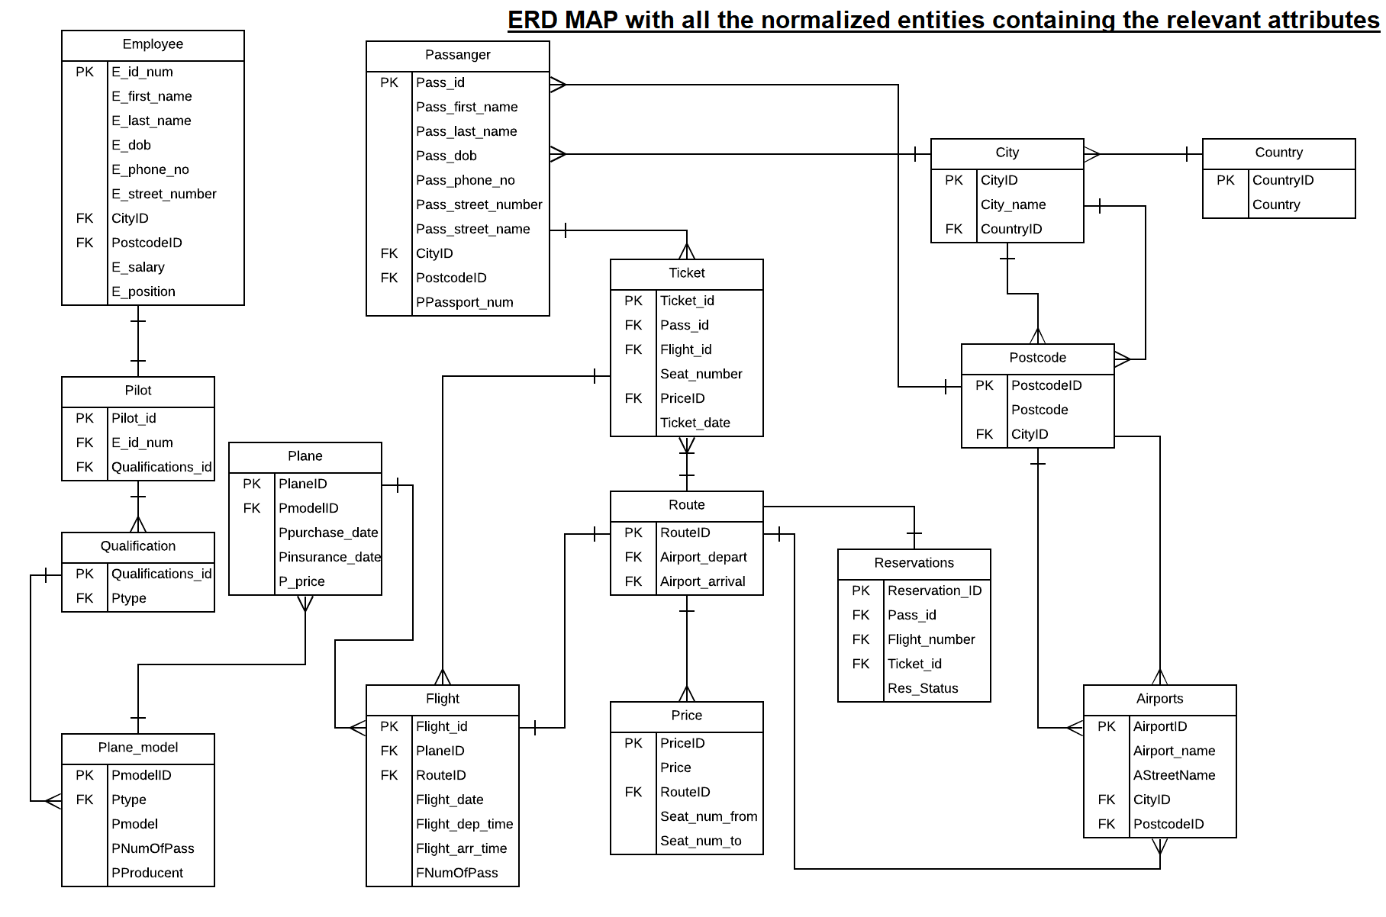

Fig 8

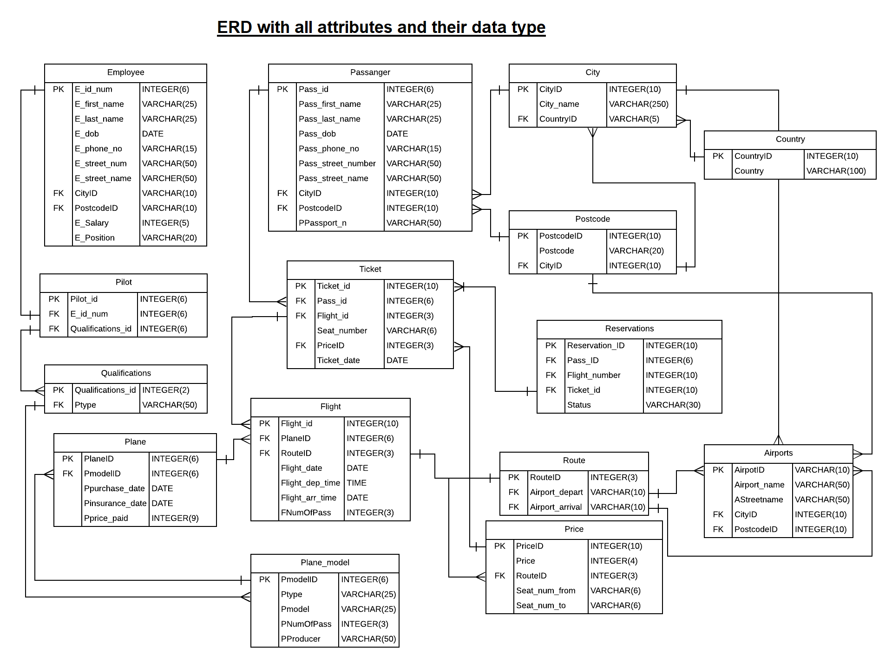

Fig 9

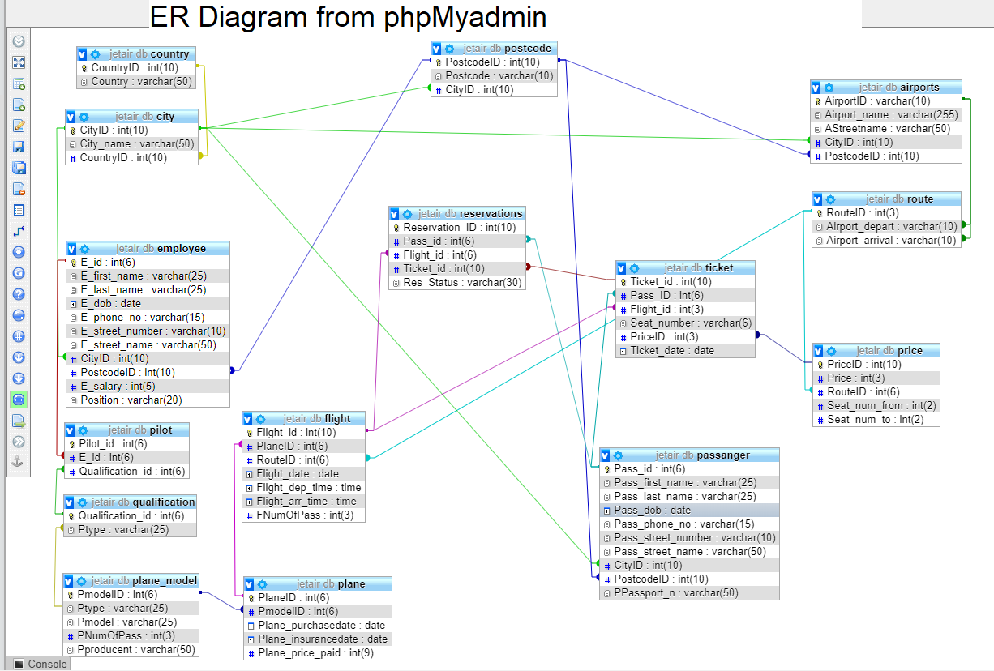

Fig 10

# Physical modelling

**SQL** stands for “Structured Query language”. It is considered one of the main reasons why relational databases are commercially successful. It is used to design and create databases. We can divide it into three groups: DDL, DML, DCL

**Data Definition Language(DDL)** is used to generate or delete a database item. It includes different statements, like CREATE, ALTER, DELETE, for different types of actions you want to do. It is used to define the database elements. **Data Manipulation Language (DML**) is used to manipulate data. It is including statements like SELECT, INSERT, UPDATE and DELETE. **Data Control Language (DCL)** is used to control the data, typically done by statements GRANT, REVOKE. Below you can find screenshots of my DDL and statement and DML statements.

I totally automated process of populating table by creating a python script that generates insert statements and keep them related, merges them all into 2 files and produces a instruction on how to step by step populate the table.

## DDL Statements

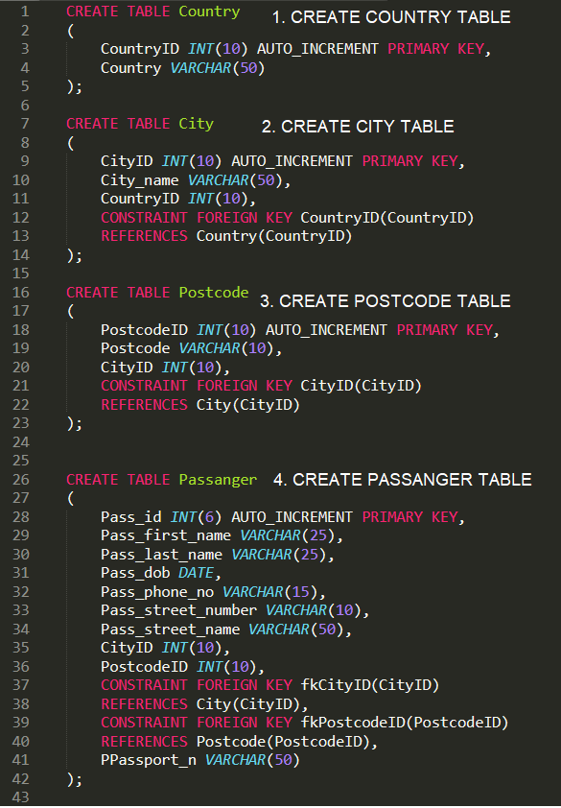 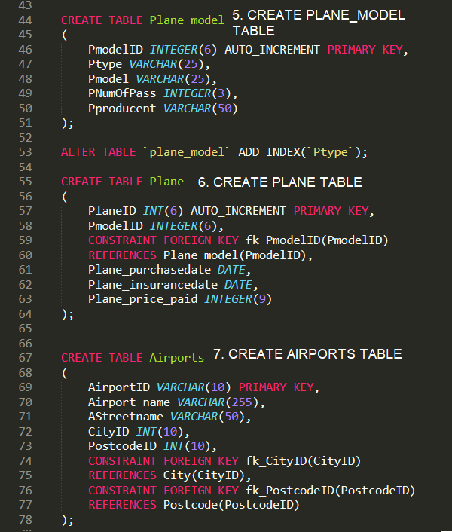

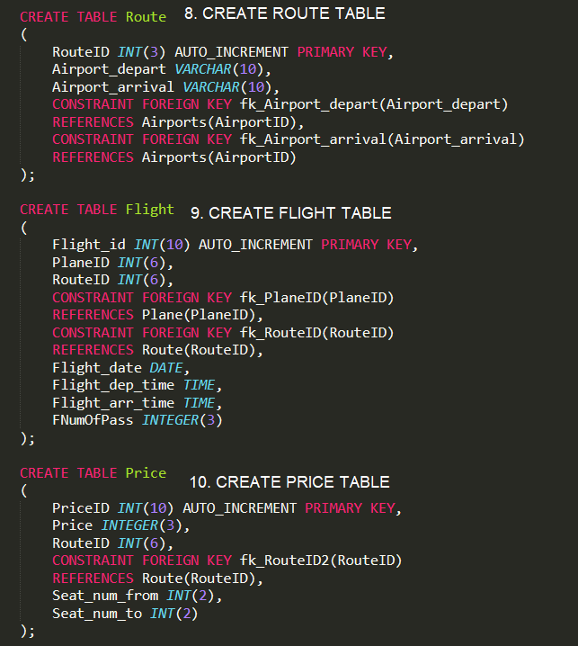 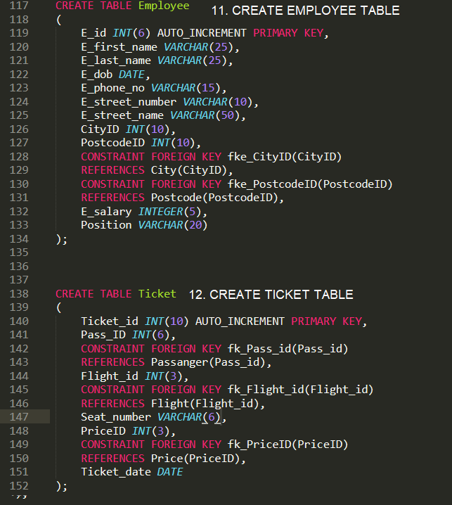

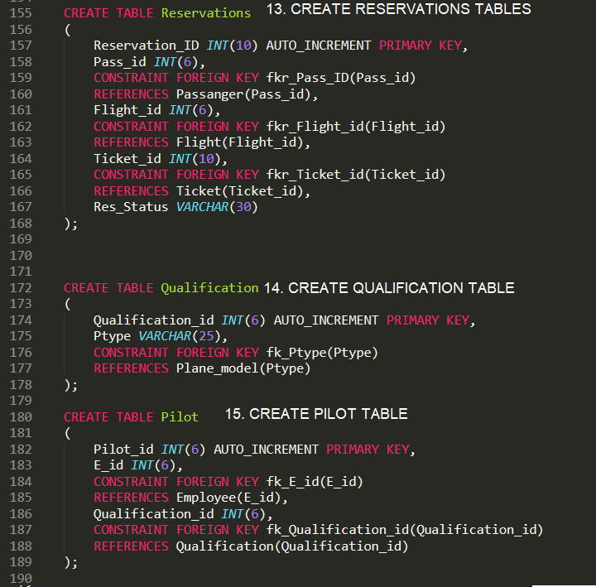

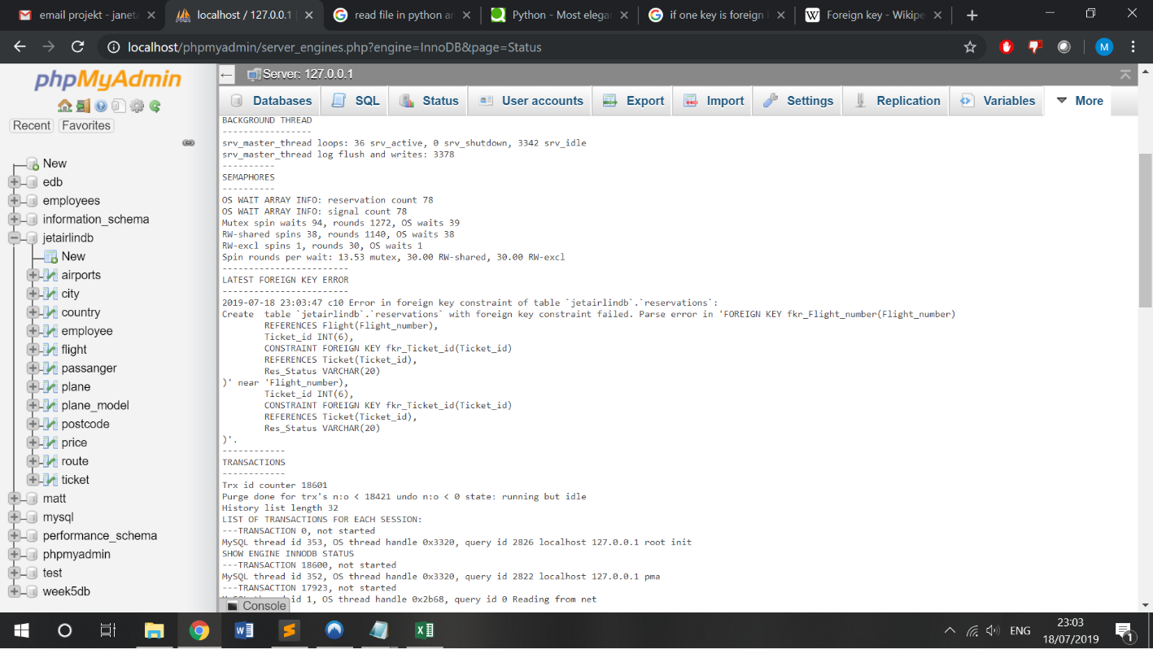

Fig 11 one the errors I came across

## DML Statements & airports.csv

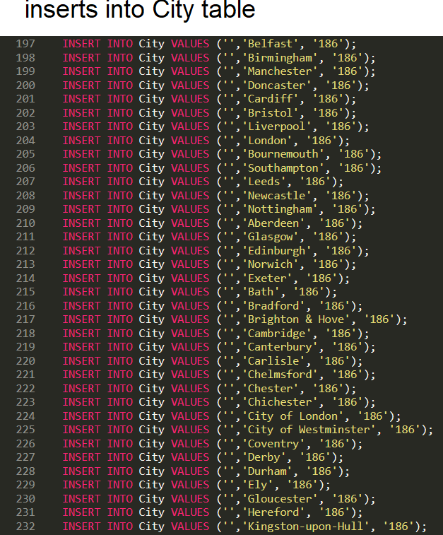 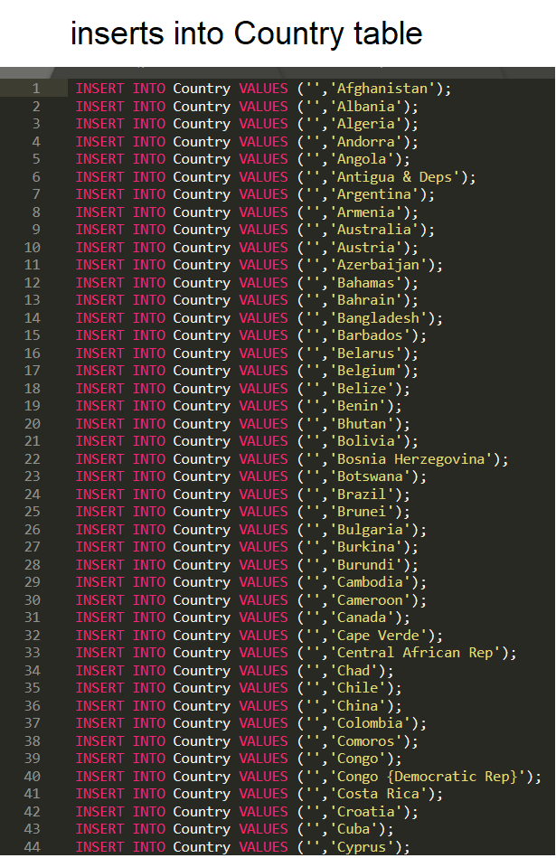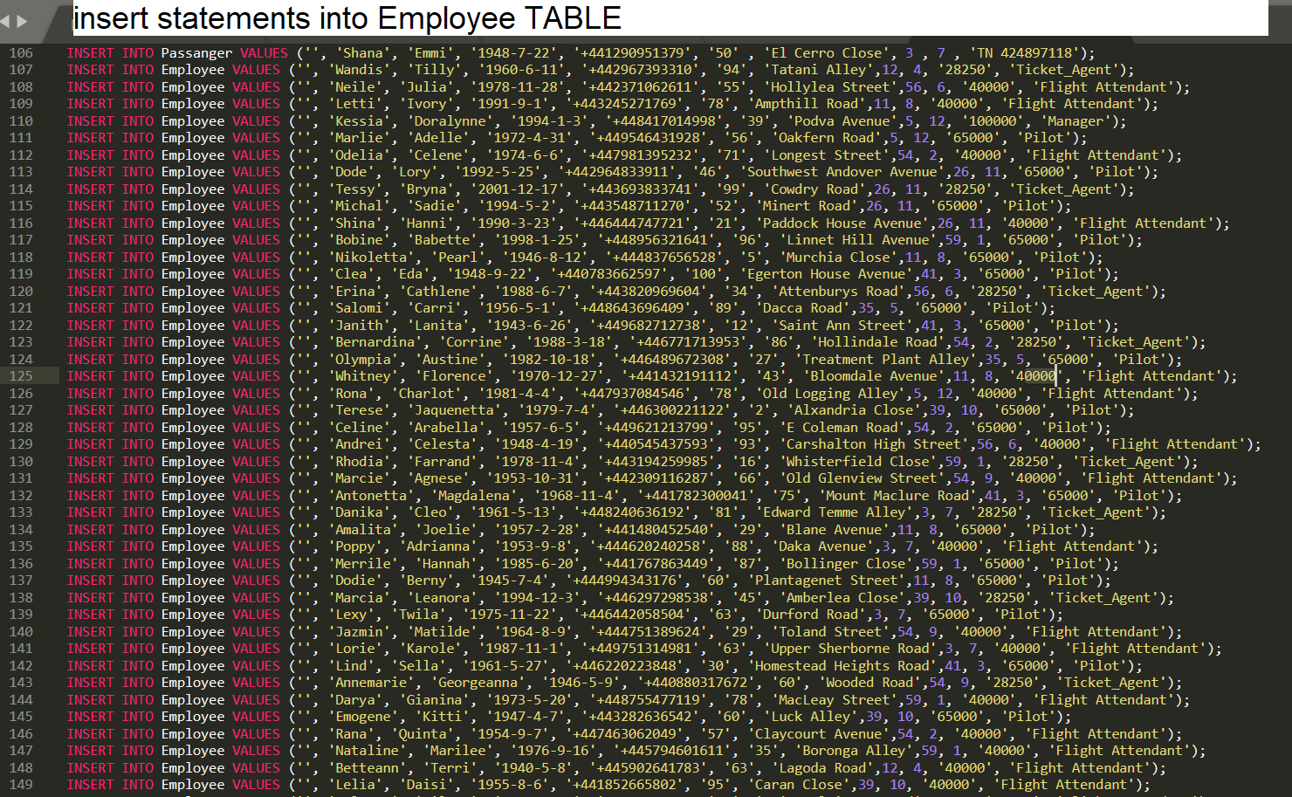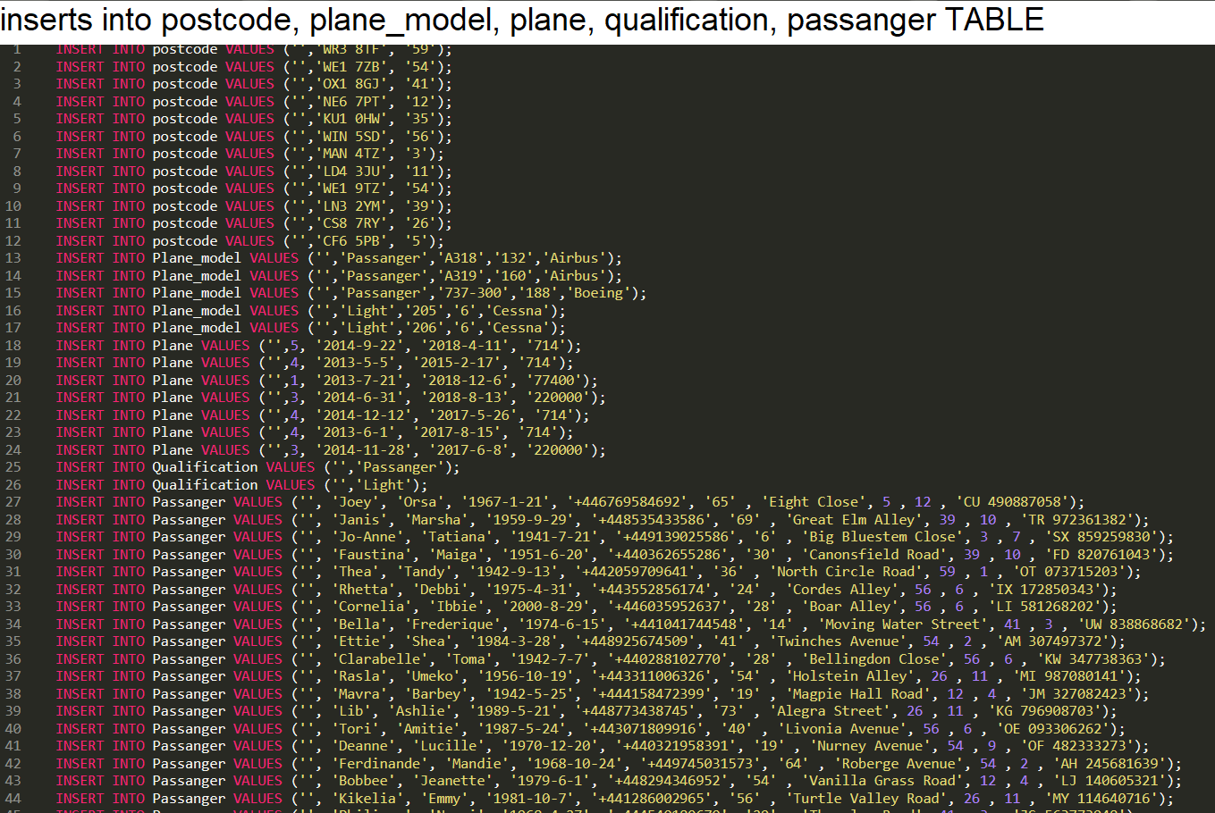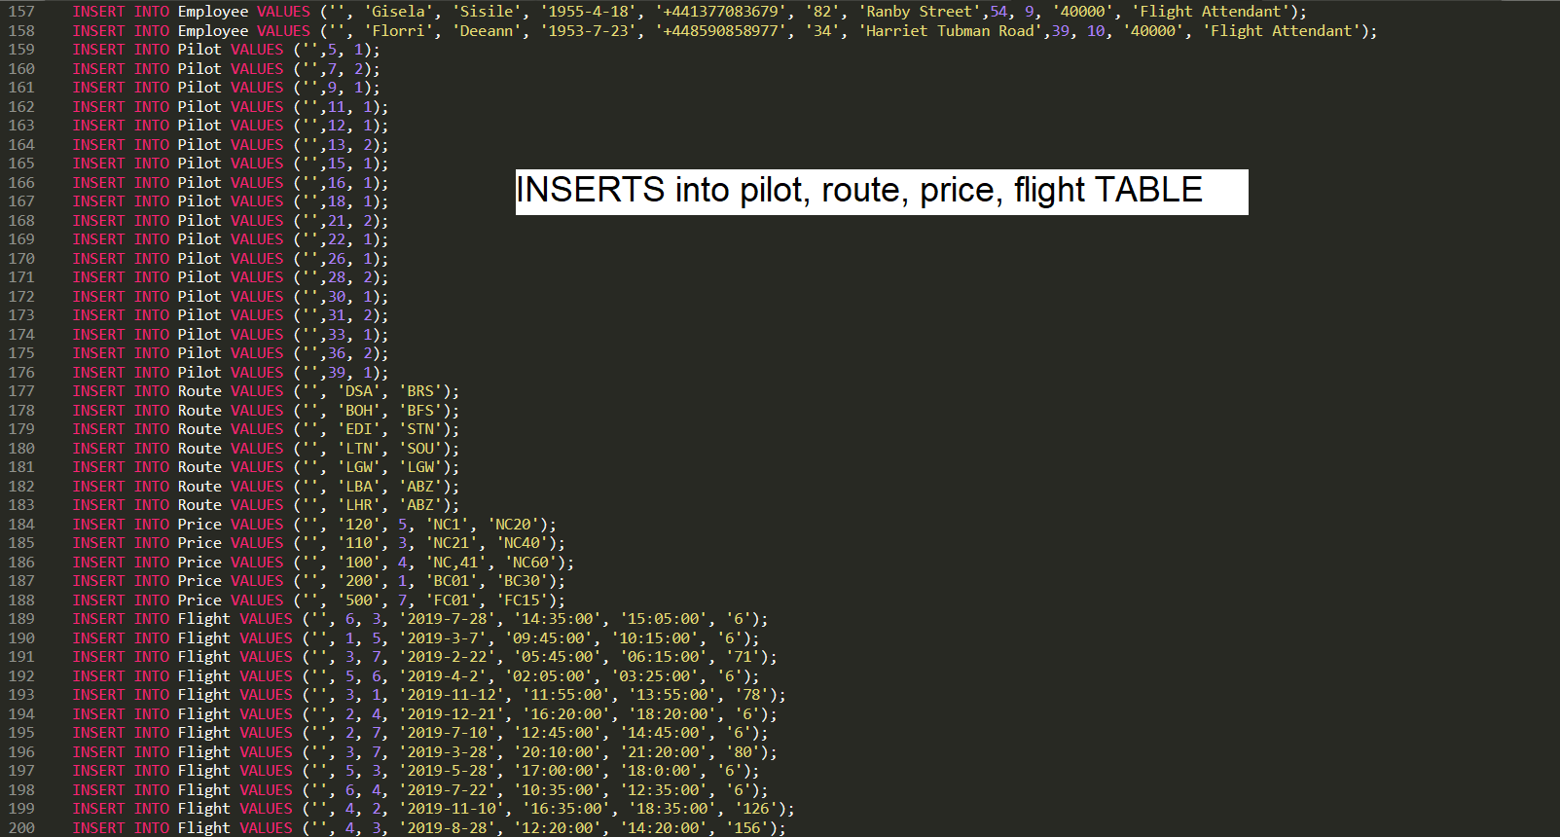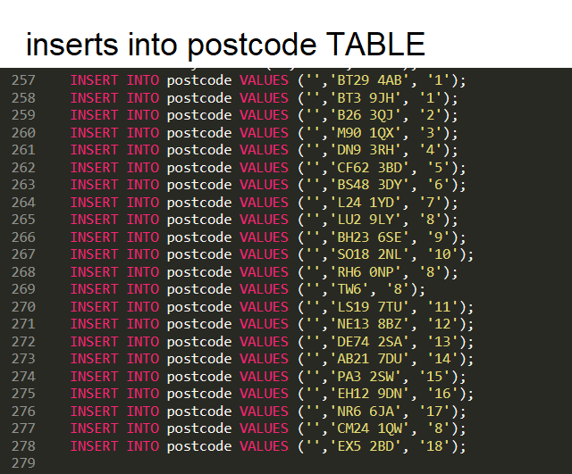 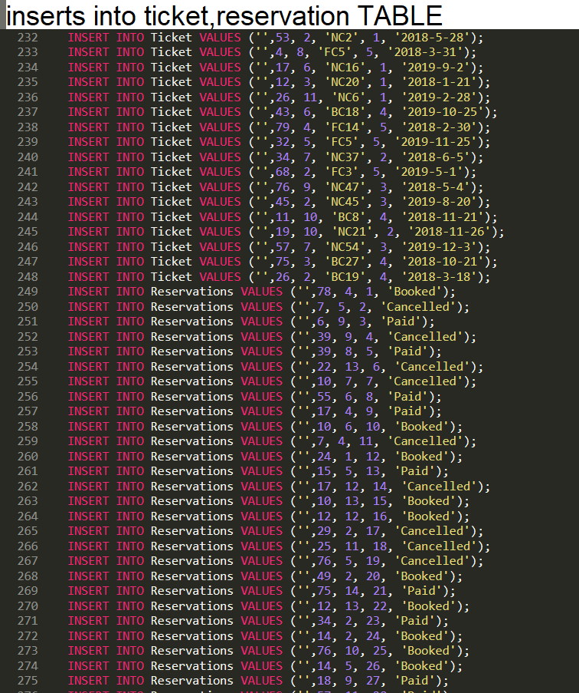

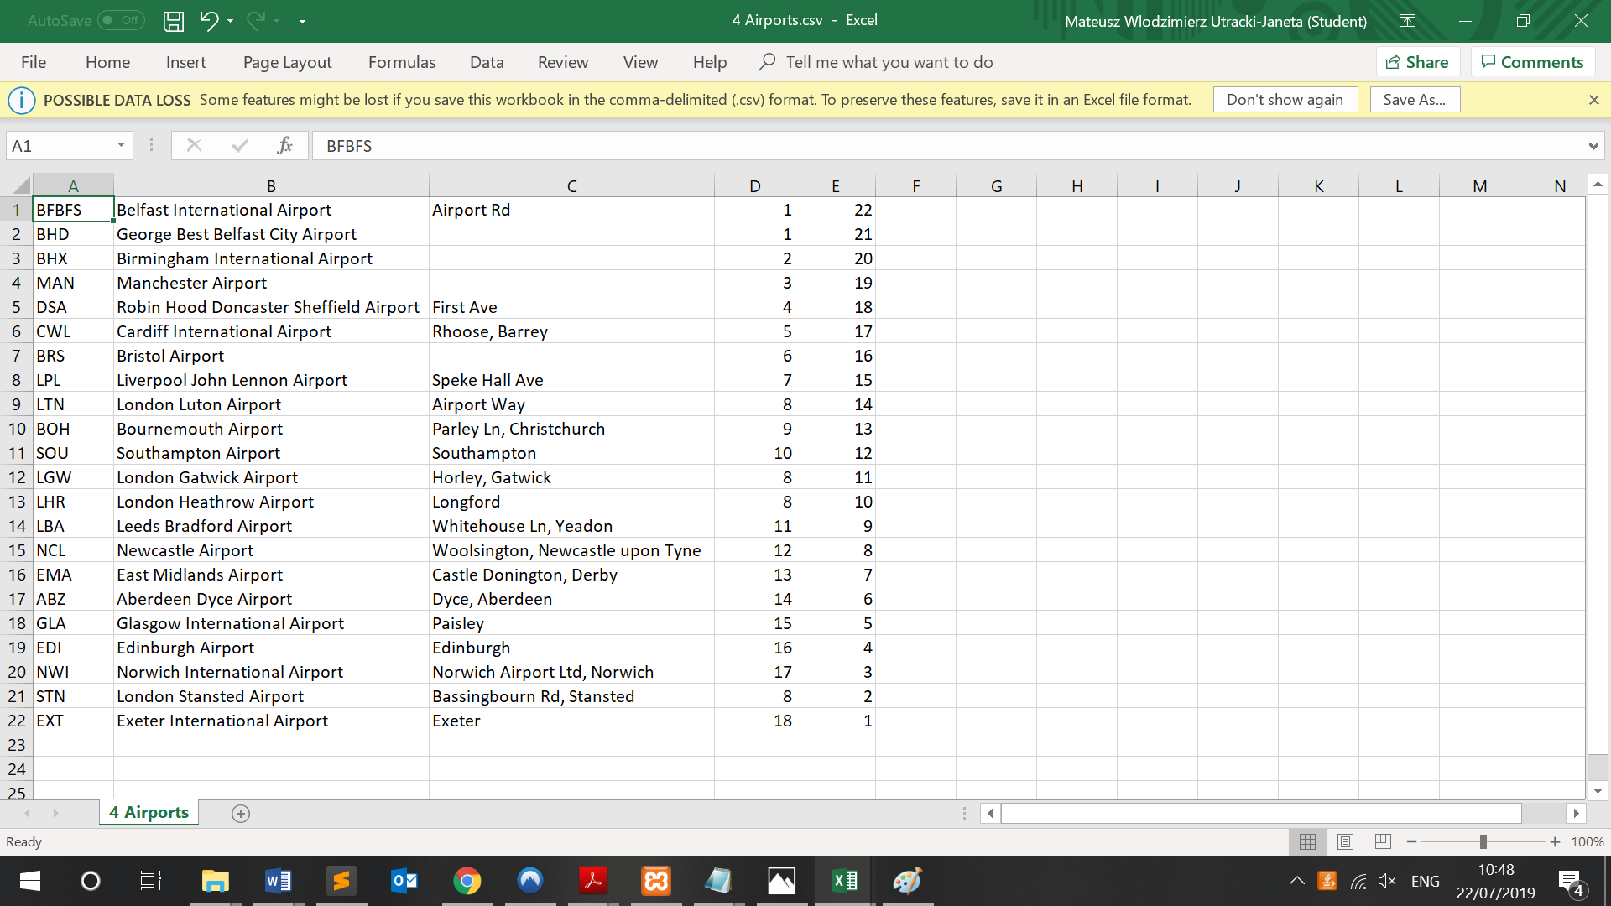

## Screenshots from phpMyAdmin

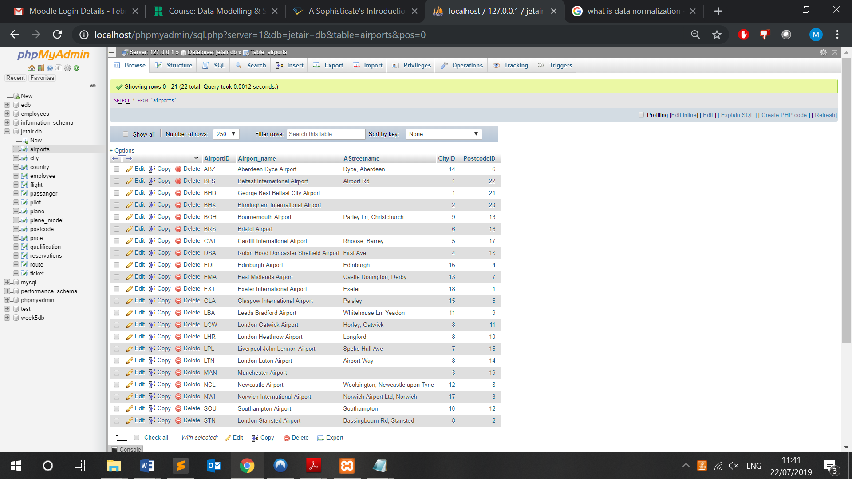

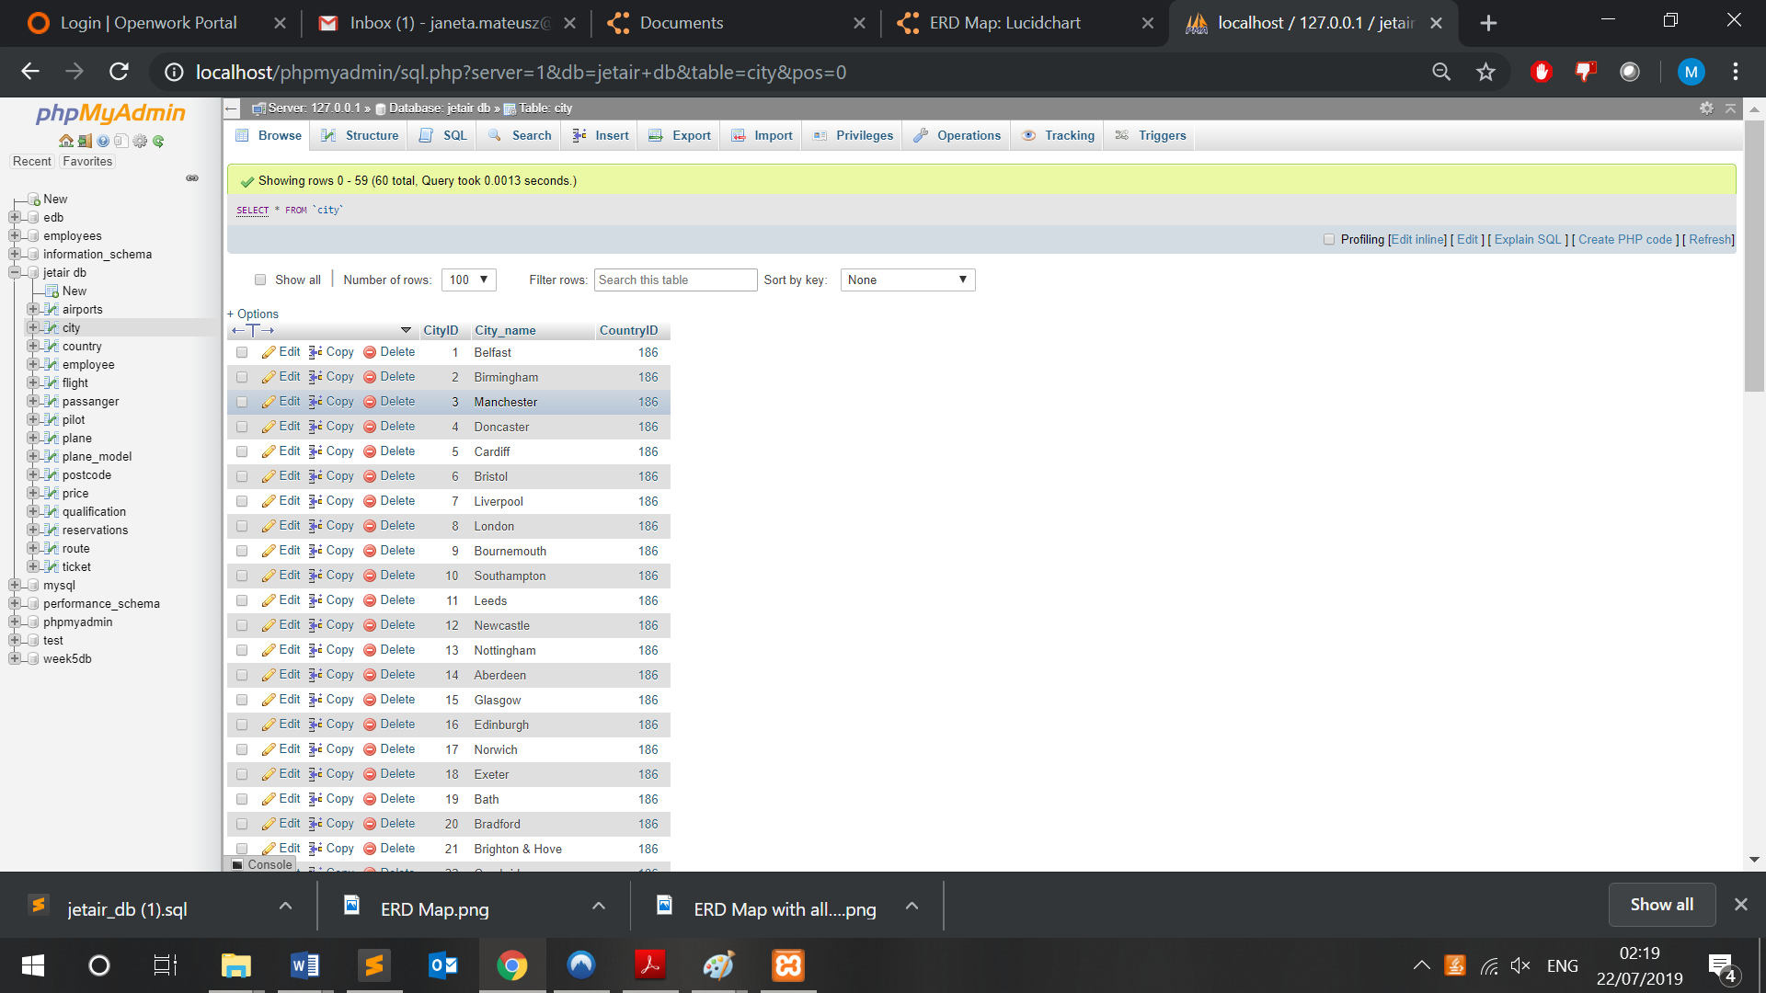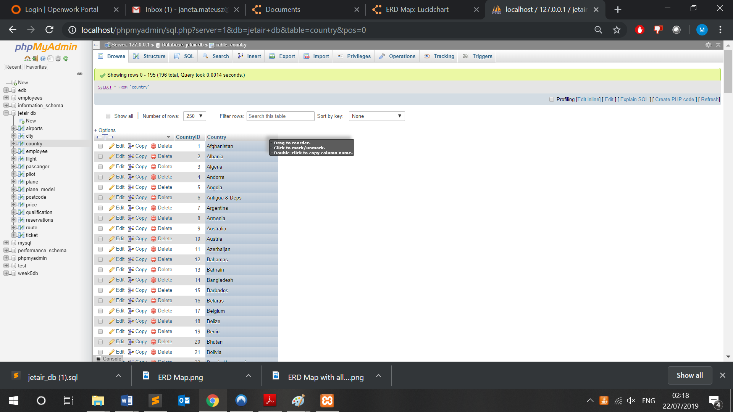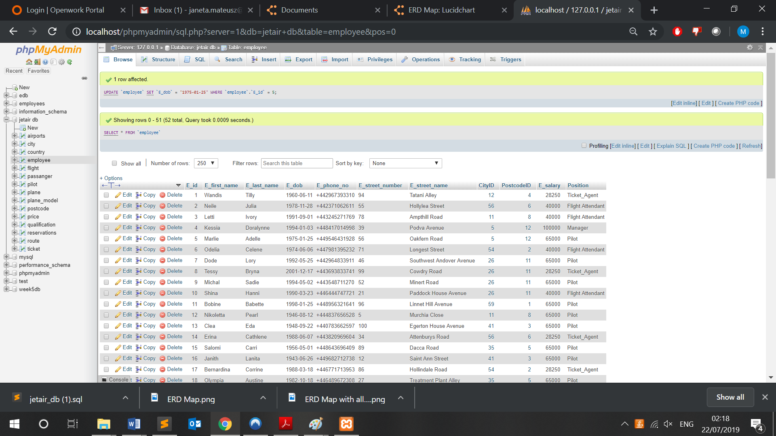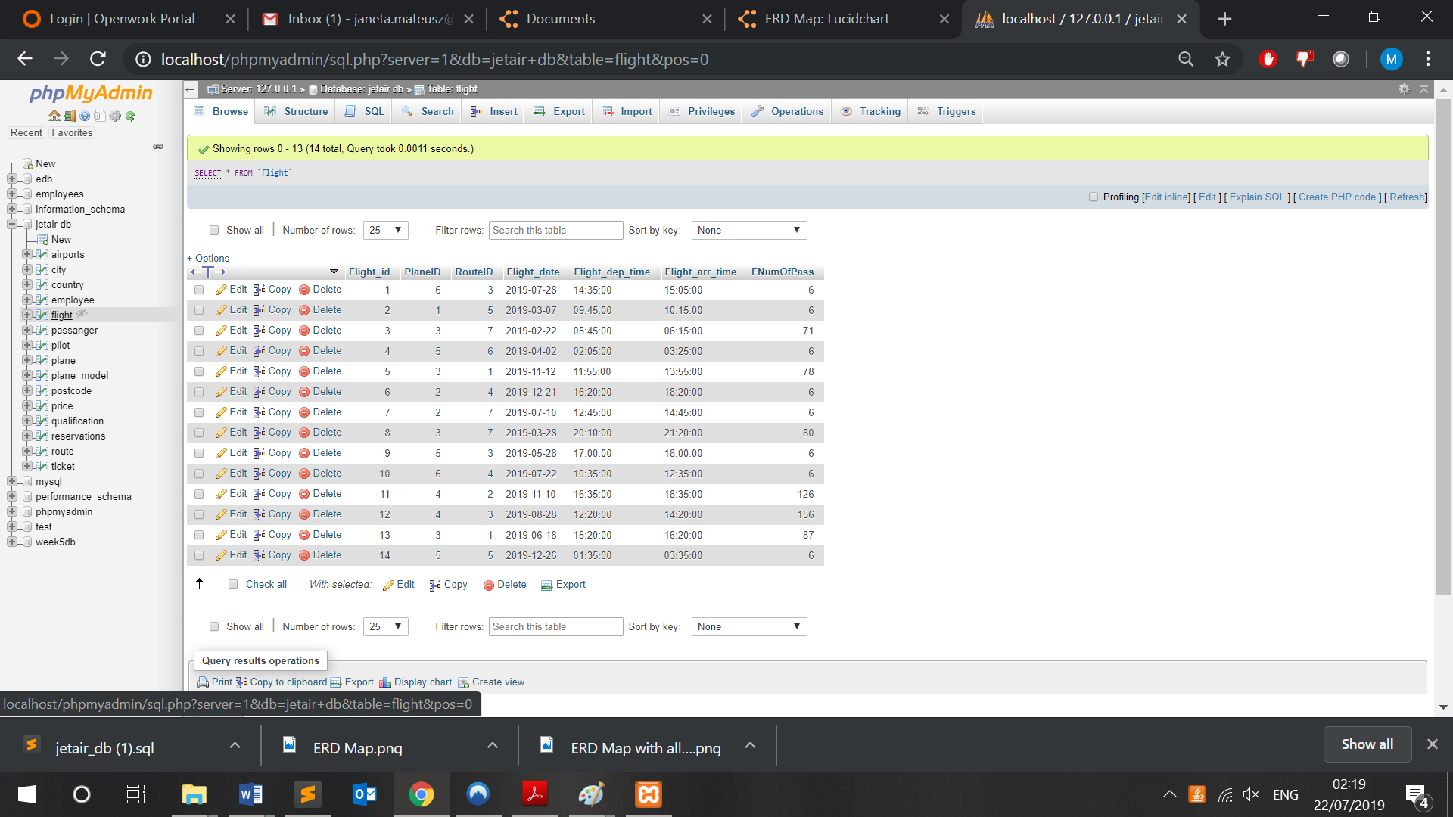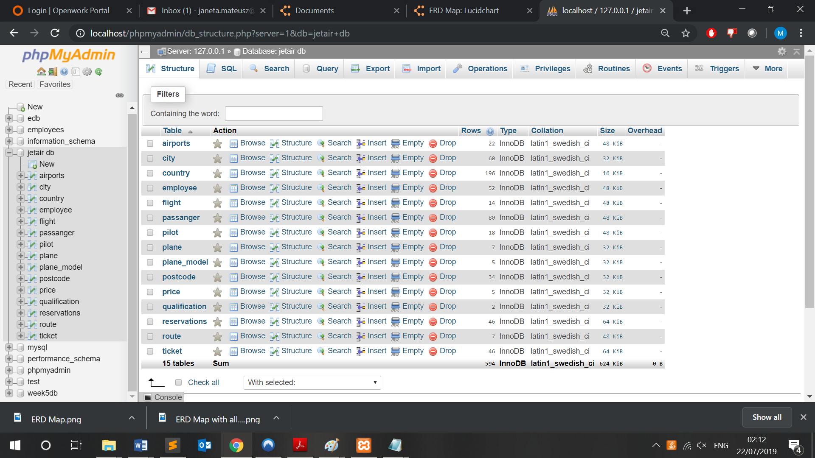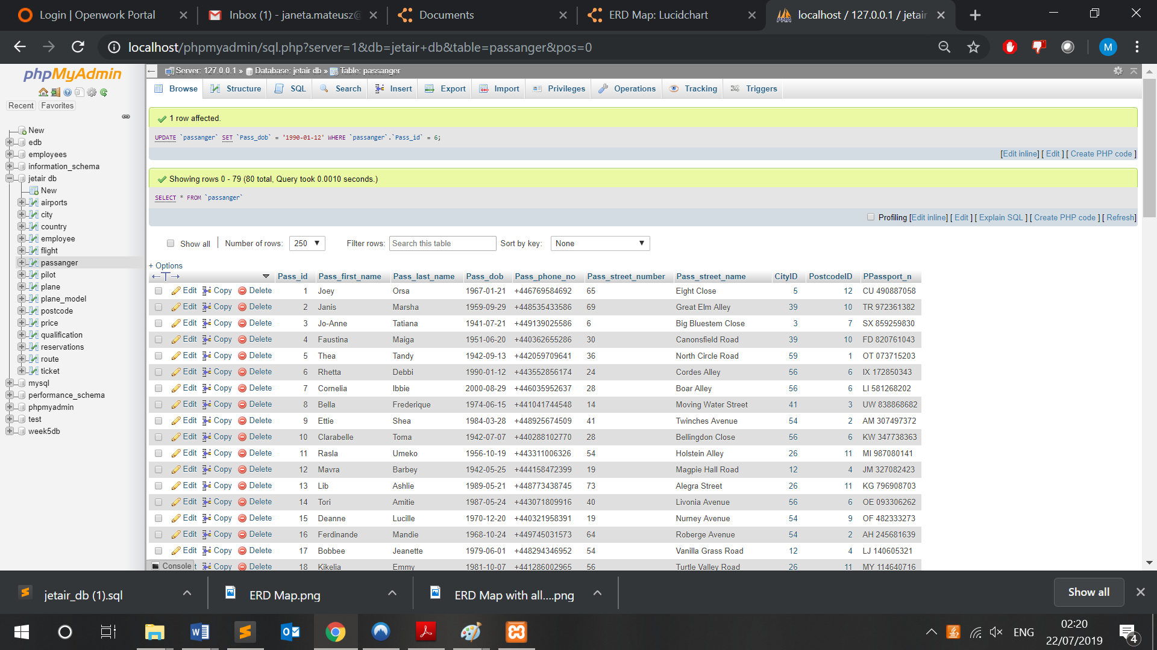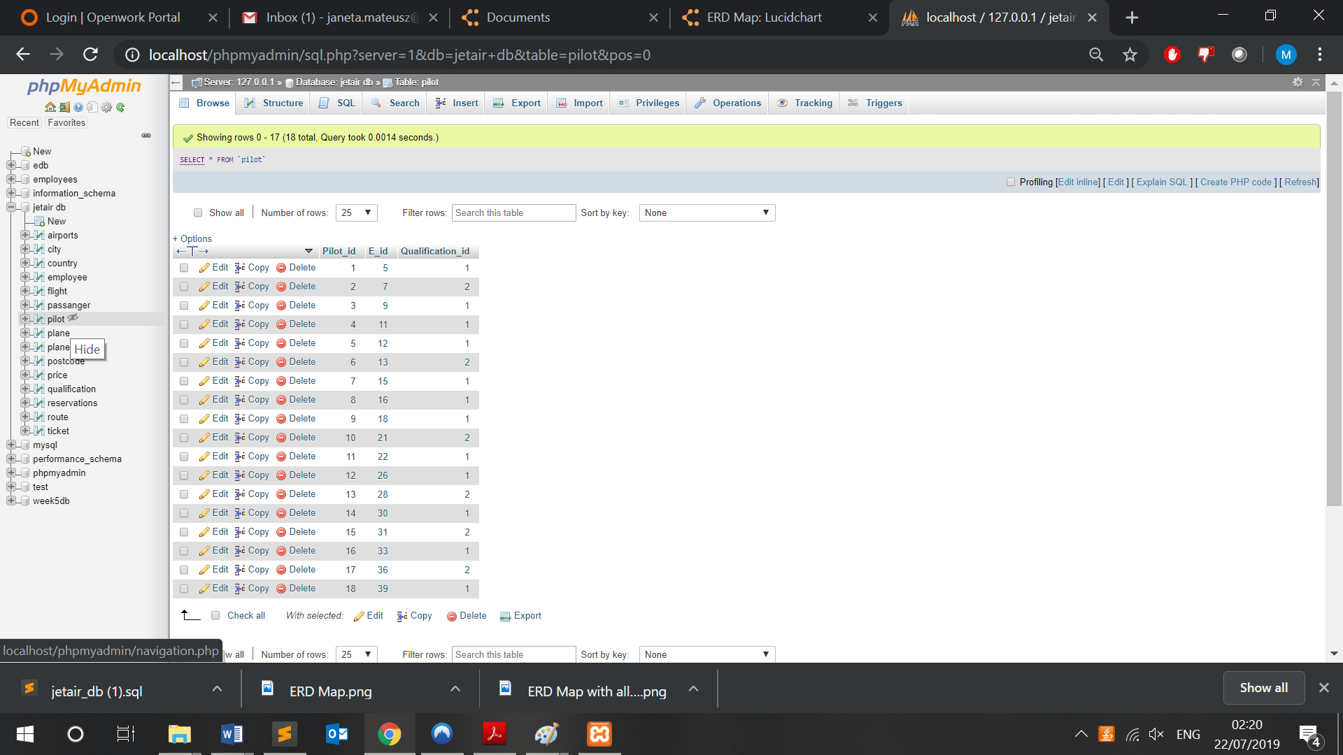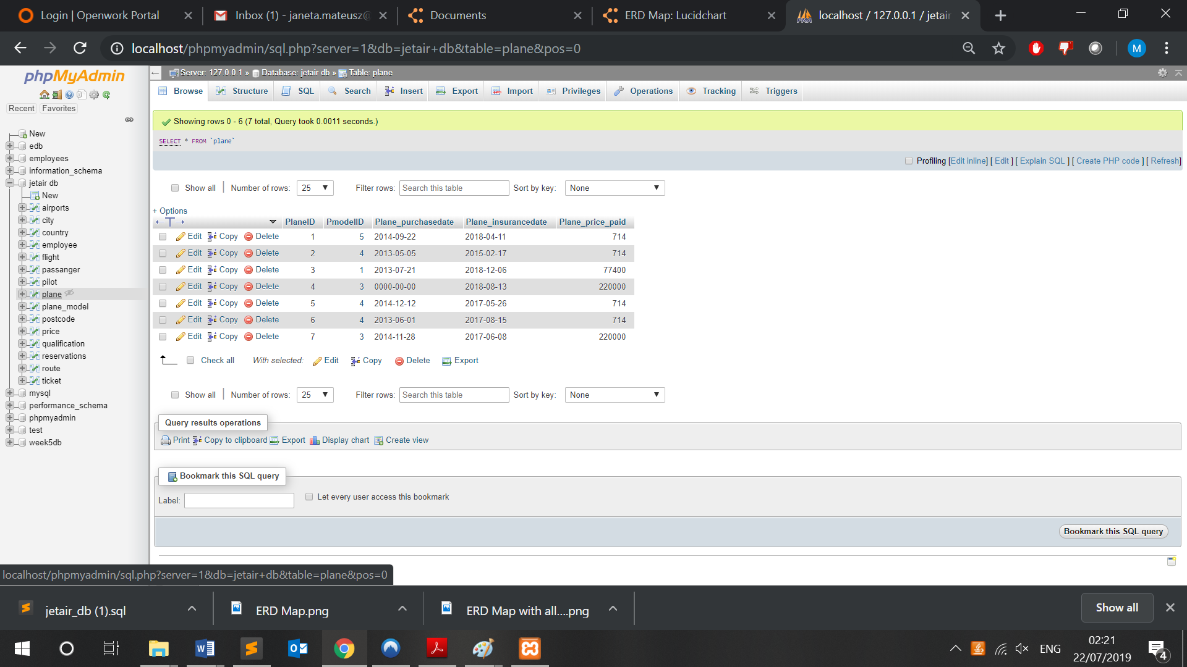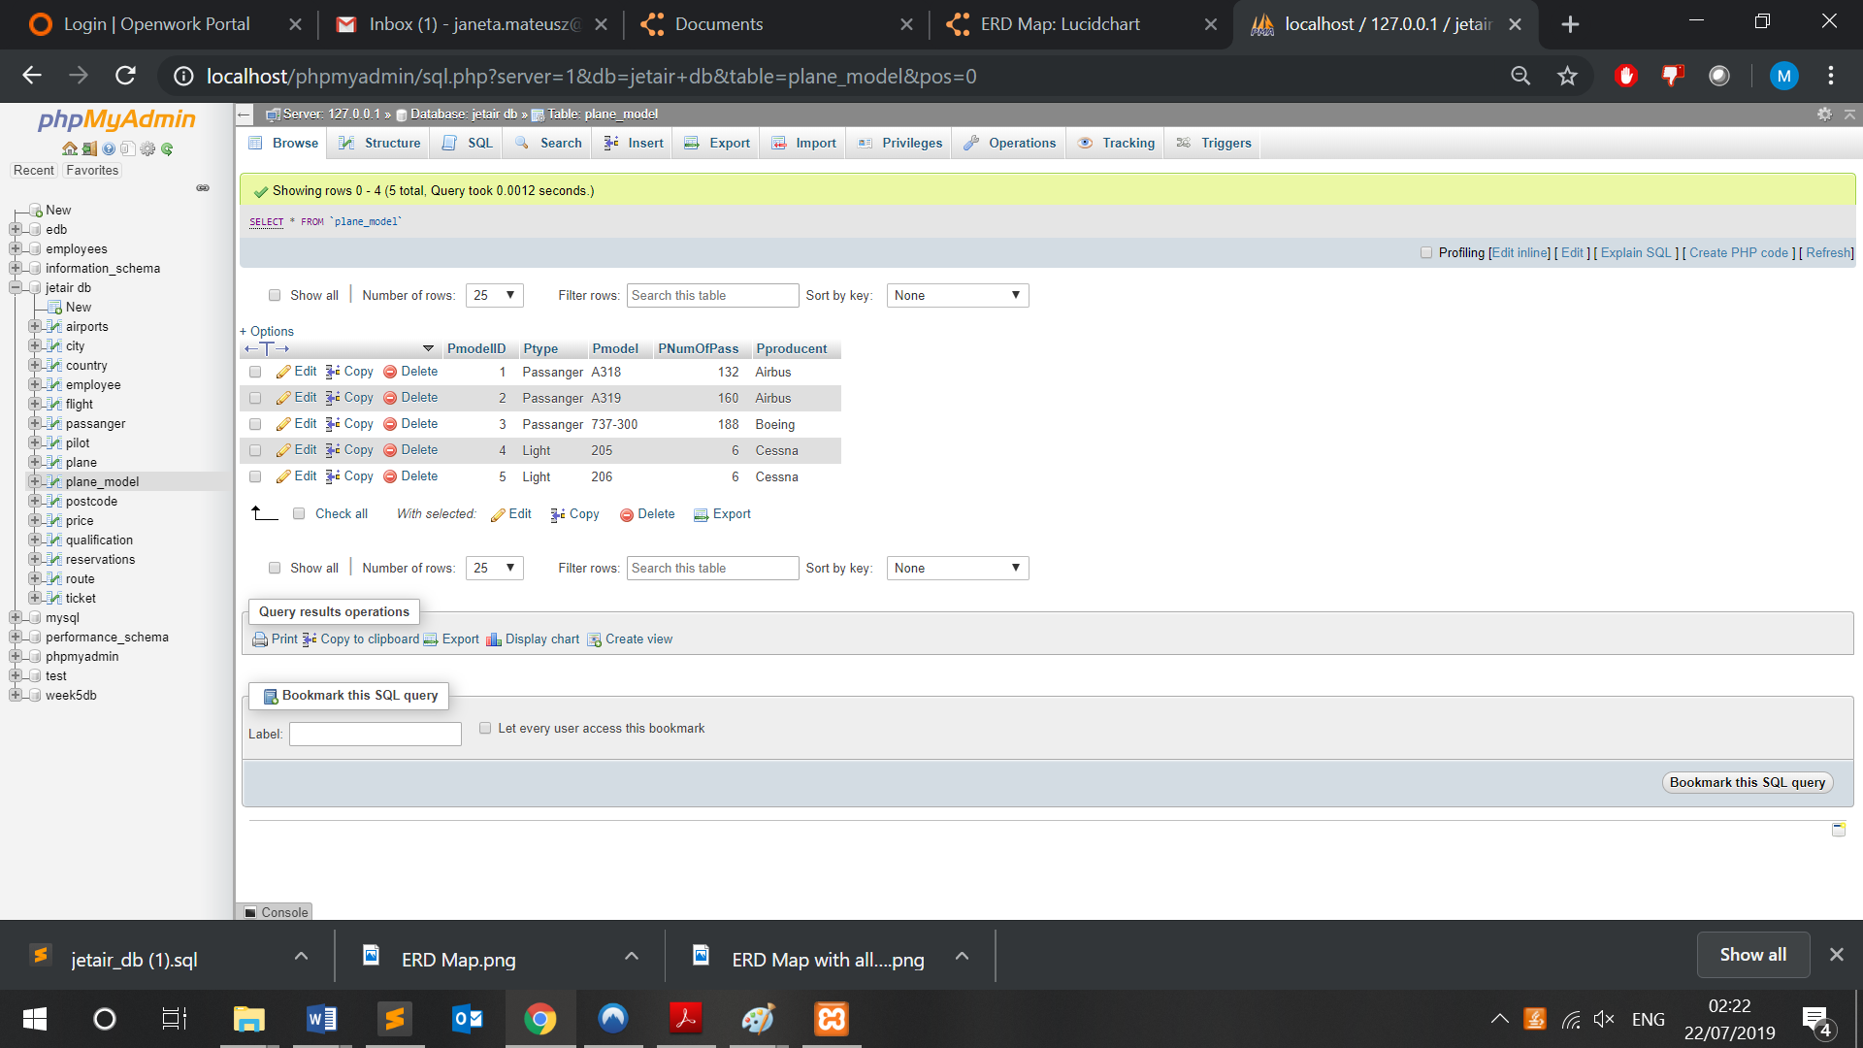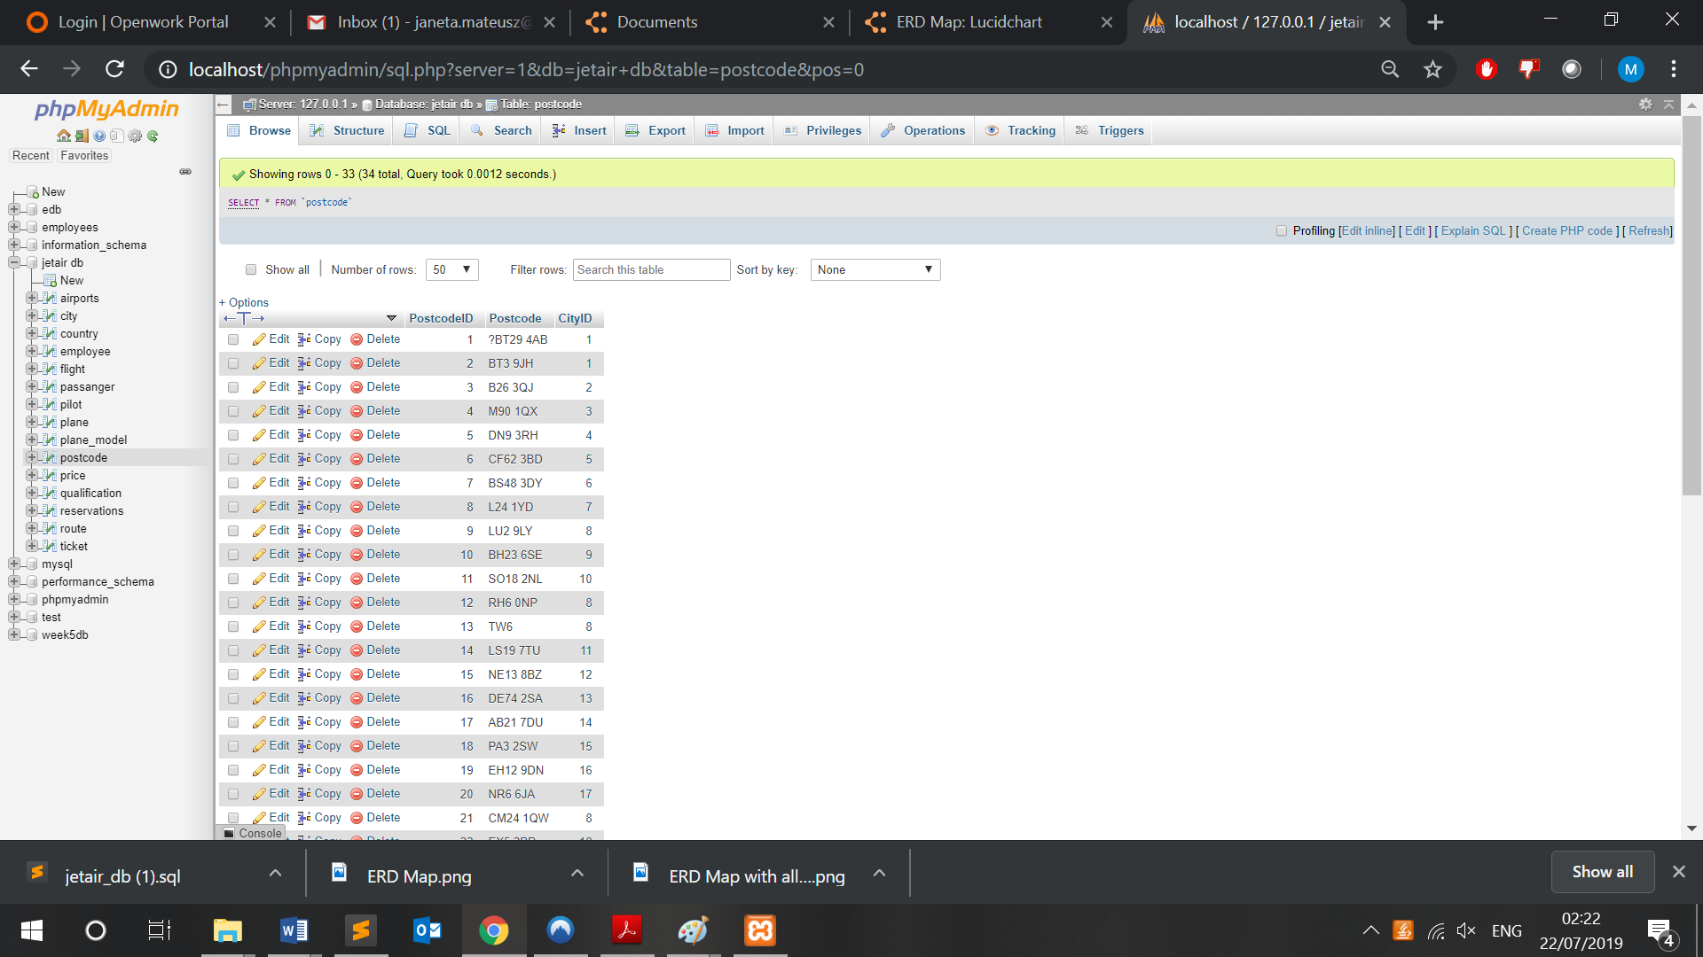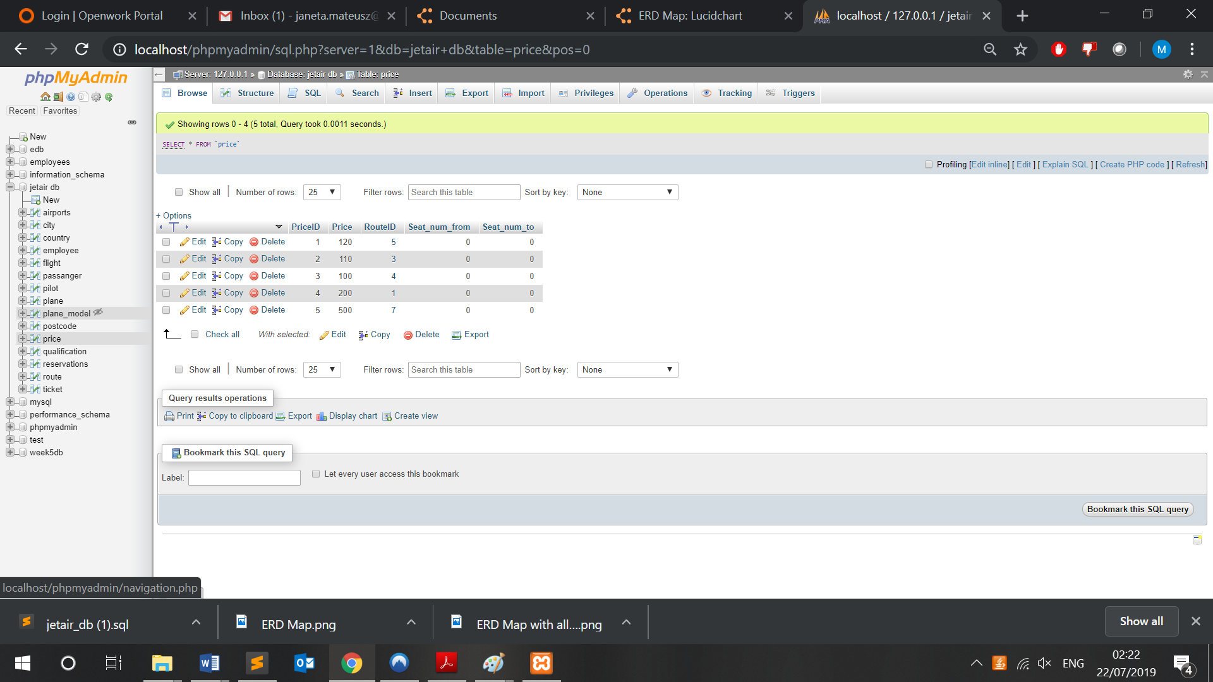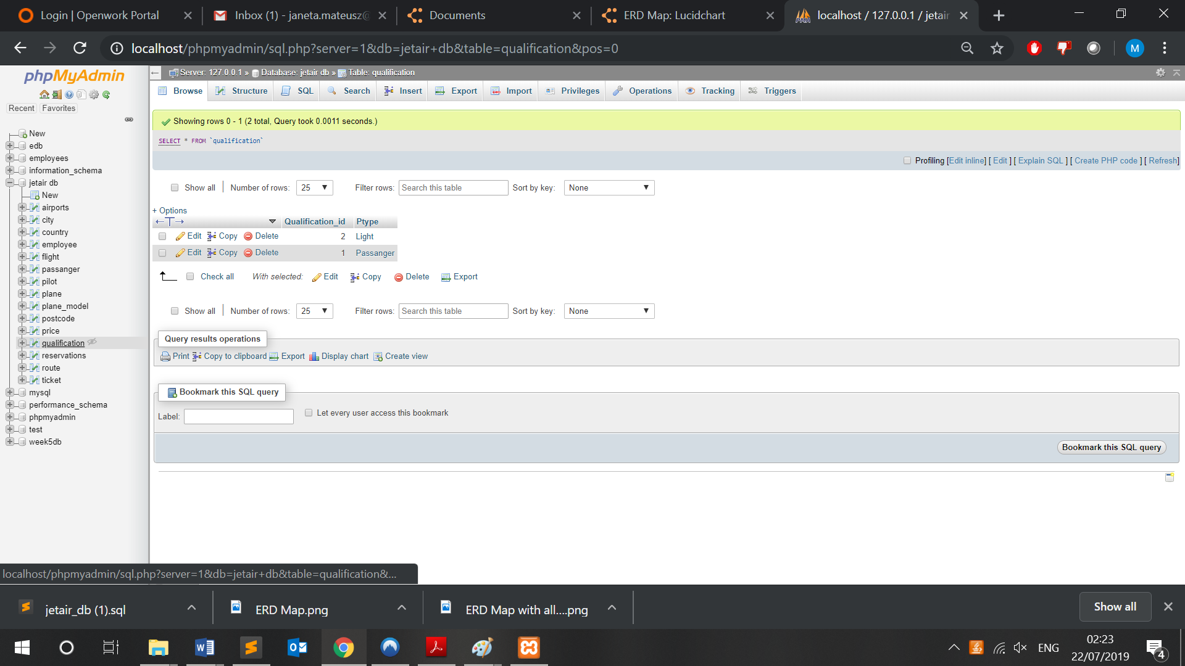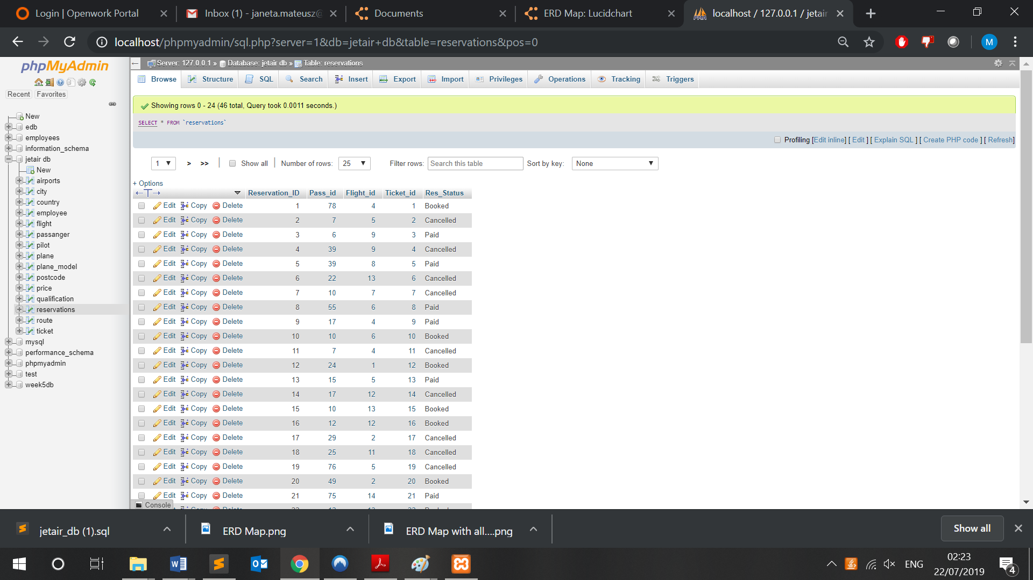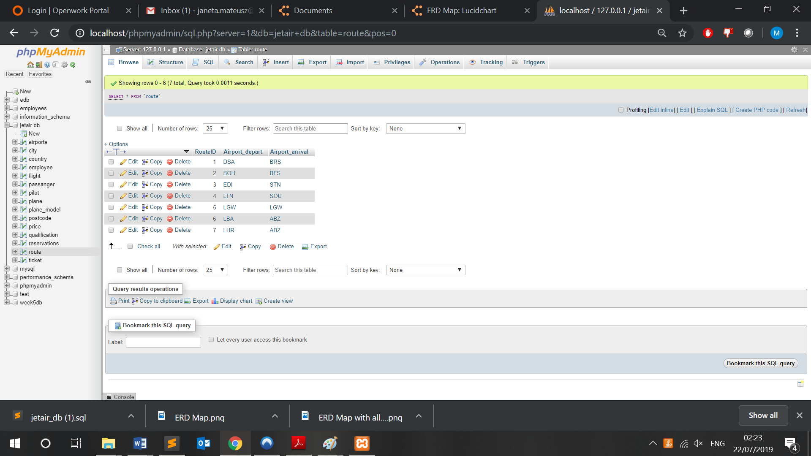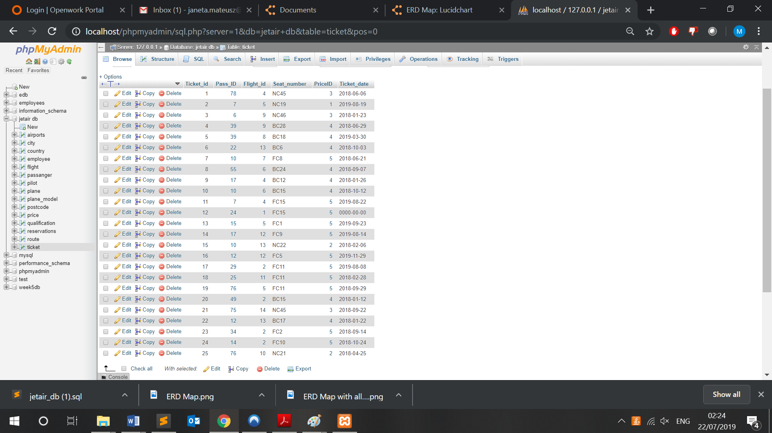

# References

1. (Conolly, 2015) Thomas M. Connolly (2015) Database systems: a practical approach to design, implementation and management (6th edition), Harlow: Pearson Education
2. (Ullman, 2014) Jeffrey D. Ullman (2014) A first course in database systems (3rd edition) Harlow: Pearson
3. (Tutorials Point, 2018) Tutorials Point (2018), DBMS Overview available at: <http://www.tutorialspoint.com/dbms/dbms_overview.htm> (accessed 04/07/2019)
4. (Techopedia, 2019) Techopedia (2019), Database Management System, available at: <https://www.techopedia.com/definition/24361/database-management-systems-dbms> (Accessed on 22/07/2019)
5. (Oracle, 2019) Oracle (2019) 5 Network Data Model Overflow available at: <https://docs.oracle.com/cd/B19306_01/appdev.102/b14256/sdo_net_concepts.htm> (accessed on 22/07/2019)
6. (Microsoft, 2018) Microsoft (2018), Structure of the Registry, available at: <https://docs.microsoft.com/en-gb/windows/win32/sysinfo/structure-of-the-registry> (Accessed on 22/07/2019)
7. (IBM, 2019) IBM (2019) Information Management System available at: <https://www.ibm.com/ibm/history/ibm100/us/en/icons/ibmims/> (accessed on 22/07/2019)
8. (Burleson, 2017) Donald Burleson (2017) Oracle Database Tips by Donald Burleson available at: <http://www.dba-oracle.com/t_object_top_down_bottom_up.htm> (accessed on 22/07/2019)
9. (Codd, 1990) Codd, E.F. (1990), The Relational Model for Database Management: Version 2 Addison-Wesley

# Appendix

1. Folder archive containing database, screenshots, DDL, DML statements, and program to generate table inserts and every material used in this work.

